Used libraries:

* **Automapper:** for mapping entities into models and vice versa;
* **EPPLUS:** library for working with excel files;
* **NUnit, Moq:** libraries for tests creation

For database creation and population was used EF migration (See Initial migration file)

For extend project with new entities, It should be used the following base classes to avoid breaking of the structure of the system:

* **ItemBase:** Holds base properties foreach entity from database table. It could be rewritten to hold common data;
* **ItemModelBase:** Holds base structure for model DTO;
* **ItemServiceBase:** Used for common logic of item services;
* **CrudControllerBase:** Used for common logic of CRUD operations;

To add new entity please follow with the next tutorial:  
1. Create new entity derived from **ItemBase** in Domain project

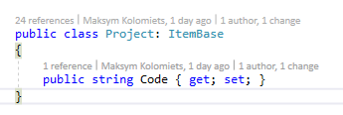

2. Create Repository derived from **IItemRepository.** Include DataBaseContext in constructor to work with Database data  
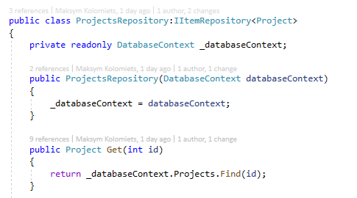  
3. Create Model derived from **ItemModelBase**

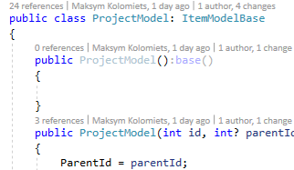

4. Create Service derived from **ItemServiceBase**

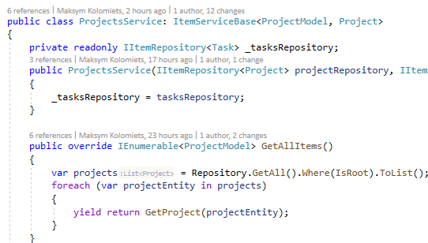

5. Create controller derived from **CrudControllerBase**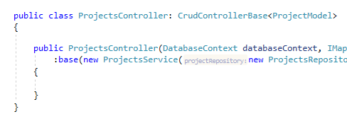

Everywhere in generic classes/interfaces should be used newly created DTOs